ANNOTATION GUIDELINES FOR SOCIAL DETERMINANTS OF HEALTH

Yujuan Fu1*, Giridhar Kaushik Ramachandran2*, Nicholas J Dobbins1  
Namu Park1, Michael Leu1, Abby R. Rosenberg3,4,5, Kevin Lybarger2, Fei Xia1,6  
Özlem Uzuner2, Meliha Yetisgen 1

1Department of Biomedical Informatics & Medical Education, University of Washington  
2Department of Information Sciences and Technology, George Mason University  
3Dana-Farber Cancer Institute, 4Boston Children’s Hospital,  
5Harvard Medical School, 6Department of Linguistics, University of Washington  
1,4Seattle, WA, USA, 2Fairfax, VA, USA, 3,4,5Boston, MA, USA  
* equal contribution

# Overview

Social history sections from clinical notes of pediatric patients will be annotated for a range of social determinants of health (SDOH), including (1) socio-demographic, (2) health care and education access, (3) living arrangements, (4) economic stability, (5) trauma, (6) mental health, and (7) substance use. The annotation involves the identification of SDOH *events*, where each SDOH *event* is represented by a *trigger* and set of entities. The trigger consists of a multi-word span (word or phrase) and a label indicating the type of SDOH (e.g. employment or substance use).

The following sections describe how each determinant will be annotated. For each annotated determinant, some entities should always be present and are required. However, some entities will not always be present. Required entities for each determinant are indicated.

## (1) Adoption

For adopted pediatric patients, it is very common that adoption information is recorded in the social history sections. *Adoption* events will be annotated with only trigger and no other attributes.

**(1) Trigger (required):** The trigger is the span that most clearly indicates a patient is adopted. The trigger span should be an adoption-related key phrase (e.g. “adopted” etc.), if present. We will only annotate adoption information of the patient. Foster care will not be annotated. This event has no other attributes.

|  |
| --- |
| **Examples** |
| He was **adopted** from <COUNTRY/> as an infant. |
| Abandoned in <COUNTRY/>, in orphanage then foster care, **adopted** by <NAME/>. |

**Example**:

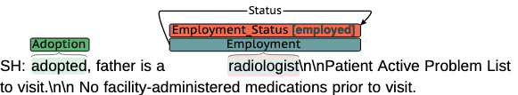

## (2) EDUCATION ACCESS

**(1) Trigger (required):** The trigger is the span that most clearly indicates an education access event is present. The trigger span will likely include some form of “grade,” “high school” etc. ***Education access is only applicable to the patient and is not relevant to the education access of others (siblings, parents, etc.).***

Table 1. Education access - trigger examples. Underlined words indicate the trigger spans.

|  |
| --- |
| **Examples** |
| Education: In **5th grade**. |
| He is currently in the **11th grade**  In foster care Heading into **junior year** of HS. (* Explanation: If both school (*HS*) and school year (junior year) are presented, please choose the school year over the school, which has more detailed information) |
| He attends a small in-home daycare (* Explanation: Daycare is not education access. Could be babysitting as opposed to actual educational programs.) |
| After-school care: mother is primary (* Explanation: "After-school" cannot be *annotated* education trigger, because it is not explicit.) |

**(2) Status (required):** *Status* indicates whether the education access event is *yes* or *no.* **Status annotation consists of assigning *a label to education access trigger.* The *Status* span should be the same as the *Trigger* span*.***

Table 2. Education access - status examples. Underlined words indicate the trigger spans.

|  |  |
| --- | --- |
| **Status label** | **Examples** |
| yes | He is currently in the **11th grade** |
| **home schooled** **kindergarten**. |
| no | Pt was attending <HOSPITAL/> but dropped out of **10th grade** about a month before the school year ended in order to work instead. |

**Examples**:

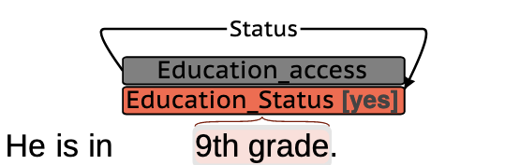

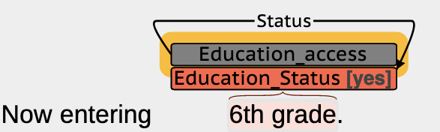

Note: Future education access is labeled with status = yes.

## (3) LIVING ARRANGEMENT

*Living status* will be annotated with the following information:

**(1) Trigger (required):** The trigger is the span that most clearly indicates a *living status* event is present. The trigger span will likely be a form of “lives” or “resides.”

Table 3. Living status - trigger examples. Underlined words indicate the trigger spans.

|  |
| --- |
| **Examples** |
| The patient does live with his family.  … the patient has been living in his father’s home…  He currently lives at home with his parents.  They have recently had a new baby, and considering ***moving*** to <CITY/> for employment in the near future.  *In* **foster care** Heading into junior year of HS (* Explanation: prefer*: “foster care”* over *“in”.* Always chose the more descriptive one*)* |
| **Negative Examples** |
| <LANGUAGE/> is primary language used *at home*.  <NAME/> has struggled with behavioral issues and ADHD and was in *residential treatment* in spring/summer <YEAR/>  Safety: Feels safe *at home* and at school*. (*\* Explanation: “At home” is not explicit enough for living status, unless a verb “live”/”resides” presents*)*  dad in <CITY/> about <NUMBER/>% of the time *(*\* Explanation: *living arrangement is only about the patient)* |

**(2) Status (required):** *Status* indicates whether the *living status* event is *current*, *past*, or *future*. ***Status annotation consists of assigning a label to living status trigger.* The *Status* span should be the same as the *Trigger* span*.***

**Table 4.** Living status - status examples. Underlined words indicate the identified trigger span.

|  |  |
| --- | --- |
| **Status label** | **Examples** |
| current | He currently lives at home with his parents.  Social History: **Living** situation prior to admit, … (Otherwise mentioned, “prior to admission” is by default current). |
| past | She was living with her parents… |
| future | She will be moving in with her parents for the summer. |

**(3) Type:** *Type* annotation consists of a span selection and a label (with both parents, with single parent, with other relatives, with foster family, with strangers*)*.

Table 5. Living status - type. Underlined words indicate the identified span.

|  |  |
| --- | --- |
| **Type label** | **Examples** |
| with both parents | He currently lives at home with his **parents**.  **Family** was living in <COUNTRY/> (If not explained otherwise, assume Family is both parents) |
| with single parent – mother / father | Pt lives at home with his **mother** and sister  Pt lives with his **father** and grandmother. |
| … the patient has been living in his **father’s home**…  Lives with **mom, stepdad**. |
| with other relatives | Lives with **grandmother, grandfather, and brother**. |
| with foster family | <PATIENT/> was voluntarily placed into **temporary foster care**.  <PATIENT/> was in two **foster homes** without any documented concerns.  No tobacco or drugs in **foster home**.  He was in **foster care** and special needs was reportedly developmental delay, though he seems normal! |
| with strangers | Relinquished to **orphanage** by <AGE/> birth mother and <AGE/> father at <HOSPITAL/> due to poverty, earthquake. |

Parents have priority over with other relatives. For the sentence “Pt lives with his **father** and grandmother.” The type label is assigned to single parent. However, for the sentence “Lives with **grandmother, grandfather, and brother**.” The type label is assigned to with other relatives.

(4) **Residence type**: Residence type annotation consists of a span selection and a label (*home, institution, homeless)*.

Table 6. Living status – residence type. Underlined words indicate the identified span.

|  |  |
| --- | --- |
| **Residence Type label** | **Examples** |
| Home | She lives alone at a **single family home**. |
| <Patient> lives with his mother, father, and 2 sisters in an **1-bedroom apartment**. |
| Social History: Lives with 2 siblings, mom and dad, 1 dog and bunny (outside) pet. No firearms. <YEAR/> **house** built - lead exposure. |
| Institution | Relinquished to **orphanage** by <AGE/> birth mother and <AGE/> father at <HOSPITAL/> due to poverty, earthquake. |
| Homeless | The family has moved <NUMBER/> times in the past three years, and has intermittently experienced **homelessness**, most recently <DATE/>-<DATE/>. |

**Note:** Foster home is labeled as type instead of residence type in the following examples. **See table 5.**

<PATIENT/> was in two **foster homes** without any documented concerns.

No tobacco or drugs in **foster home**.

**Annotation Examples:**

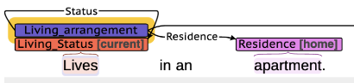



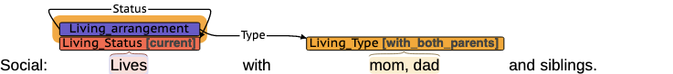

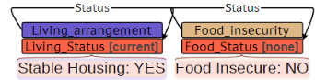

For stable housing, we cannot assume it should be labeled as "Residence - Home". Because Stable means just not changing, whereas residence/home implies ownership. Just a caption, without knowing which type of residence is.

Economic stability will be determined with the employment status of caregivers.

## (4) EMPLOYMENT

*Employment* will be annotated with the following information:

**(1) Trigger (required):** The trigger is the span that most clearly indicates an employment event is present. The trigger span should be a work-related key phrase (e.g. “works,” “occupation,” “employed,” “unemployed,” “on disability”, “retired,” “homemaker,” etc.), if present. Otherwise, it should be a specific profession. In notes with employment-related subheadings, like “Occupation:…” or “Employment:…,” the subheading without the colon (i.e. “Occupation” or “Employment”) should be the trigger.

Table 7. Employment - trigger examples. Underlined words indicate the identified span.

|  |  |
| --- | --- |
| **Priority** | **Examples** |
| 1. Employment subheading | **Employment**: Nurse |
| 2. Work-related key phrase | Mother used to be employed as a registered nurse.  … she works at a nursing home.  She worked as a travel agent.  Social: Lives with mom and grandparents, mom **working** w/ Transport. (Working(verb) is preferred over “transport” (profession))  … she is retired.  Father is unemployed.  …mother is on disability.  … the mother is a homemaker.  just finished 10th grade, works at <LOCATION/>'s. (We are not annotating children. Because Children does not contribute a lot to the economy) |
| 3. Profession | She is a full-time student at University.  The mother is a registered nurse by profession.  Father is an office manager for a gravel company.  SOCIAL HISTORY: Lives with father <NAME/>' (an **<Profession/>**) and mother <NAME/> (a **<Profession/>** for <LOCATION/>') and has grandparents visiting providing support.  Mom is currently in school working on **master’s program**. (* Explanation: choose the more informative trigger, “*master’s program*” over “*school*”.) |

**(2) Status (required):** ***Status annotation consists of assigning a label* (*employed*, *unemployed*, *retired*, *on disability*, *student*, or *homemaker*) *to employment trigger.* The *Status* span should be the same as the *Trigger* span*.*** Because our population is pediatric patients, reported employment status is usually associated with the caregivers. Where a previous employment is described without a description of current employment, the status label should be *unemployed*, unless the note explicitly describes retirement, being on disability, etc. In some cases, a caregivers’ employment status may be discussed in multiple sentences. The annotated notes will likely be processed sentence-by-sentence, and individual events should be confined to a single sentence, where possible (see “Defining Events” section at the end of this document for details). If there is an *employment* trigger in each sentence, then separate *employment* events should be created in each sentence. The *on disability* label should only be applied to explicit descriptions of receiving disability benefits (e.g. "on SSI" and "receiving disability benefits") and should not be applied to the presence of disabilities (e.g. "is disabled").

Table 8. Employment - status. Underlined words indicate the trigger span.

|  |  |
| --- | --- |
| **status value** | **Examples** |
| employed | Occupation: works  … mother works at a nursing home.  Father **Currently works** in construction.  Father is currently taking some of his **parental leave**. |
| Unemployed  \**Unless otherwise explicitly stated as “homemaker”, we annotate them as unemployed, based on the goal of deciding economic stability* | Father is unemployed.  Father used to work, but **currently unemployed**, and helping with kids.  <YEAR/>: Pt lives with mom and dad. 1st child. Extended family live in <COUNTRY/> Mom plans to **stay at home**.  She **provides daycare** for 2 children.  She is a <PROFESSION/> who **quit here post-doctoral fellowship** to care for the child. |
| retired | … father is a retired engineer. |
| on disability | …mother is on disability.  father is re-married, **on medical leave** from his job… |
| student | Mother is a full-time student at University. |
| homemaker | … Mother is a homemaker. |

**Examples:**

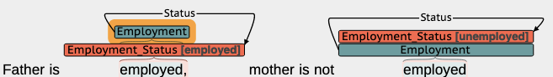

## (5) Food INSECURITY

**(1) Trigger (required):** The trigger is the span that most clearly indicates a food insecurity event is present. The trigger span will likely include some form of “food stamps,” “Food insecurity” etc.

Table 9. Food insecurity - trigger examples. Underlined words indicate the identified span.

|  |
| --- |
| **Examples** |
| They receive **food stamps**. |
| Mother denies **food insecurity**, and has stable housing.  Denies **food insecurity**, difficulty accessing transportation, denies any poor support. |

**(2) Status (required):** ***Status annotation consists of assigning a label (current, past, none) to food insecurity trigger.*****The *Status* span should be the same as the *Trigger* span*.***

**Table 10.** Food insecurity - status examples. Underlined words indicate the trigger span.

|  |  |
| --- | --- |
| **Status label** | **Examples** |
| current | They receive **food stamps**. |
| past | The family had **food insecurity** in the past. |
| none | Mother denies **food insecurity**, and has stable housing.  Denies **food insecurity**, difficulty accessing transportation, denies any poor support.  **Food Insecure**: NO |

**Example**:

Although it states no food insecurity here, WIC is for low-income population. It is also a kind of food insecurity.

## (6) TRAUMA

**(1) Trigger (required):** The trigger is the span that most clearly indicates a prior trauma event is present. Each reference to trauma should be annotated with a separate trigger.

Table 11. prior trauma - trigger examples. Underlined words indicate the identified span.

|  |  |
| --- | --- |
| **Examples** | **Notes** |
| <PATIENT/><AGE/> mom **died** of cancer in the past year. |  |
| Violence/trauma: patient reports father has been "**mentally abusive**" |  |
| +Hx of **physical** and **emotional abuse** (by mother, ..., would **emotionally abuse** him. | This sentence have multiple trauma events. |
| Has anything scary ever happened to you or your family: **Car accident** <DATE/> |  |
| Has prior history of **bullying** at public school |  |

**(2) Status (required):** ***Status annotation consists of assigning a label (yes, no) to trauma trigger.* The *Status* span should be the same as the *Trigger* span*.***

Table 12. prior trauma - status examples. Underlined words indicate the trigger span.

|  |  |
| --- | --- |
| **Status label** | **Examples** |
| yes | <PATIENT/><AGE/> mom **died** of cancer in the past year.  Parents **separated** when <PATIENT/> was <AGE/> old, due to **domestic violence** which he witnessed as an infant and toddler. |
| no | **Violence/trauma**: not reported  Denies **sexual abuse**. |

**(3) Type (required):** ***Type annotation consists of assigning a label (divorce/separation, loss, psychological, physical, domestic violence, sexual) to trauma trigger.*** **The *Type* span should be the same as the *Trigger* span*.***

Table 13. Prior trauma - status examples. Underlined words indicate the trigger spans.

|  |  |  |
| --- | --- | --- |
| **Type label** | **Definition** | **Examples** |
| Divorce / separation |  | Parents are going through a **divorce** currently.  Her parents are **divorced**.  Parents **divorced/separated**, single custody.  Lives with Mother; **FOB not involved**  Lives with mom, **stepdad**, ... every other week  Mom has **supervised visits Birth father lives** in <CITY/>, supervised visits  <NUMBER/> times a year "Daddy <NAME/>" was her acting father, was with Mom during her pregnancy with LOCATION (Choose the longer span, if unsure) |
| loss | Death of a parent or caregiver or other family member or friend. | <PATIENT/><AGE/> mom **died** of cancer. |
| *psychological* | Parent or other adults swear, insult or put the patient down  Patients or other adults swear acts in a way that made patient is afraid that the patient would be physically hurt | Violence/trauma: patient reports father has been "**mentally abusive**"  Possible physical abuse in <COUNTRY/> and/or <COUNTRY/>, likely made to work around the house and **emotionally neglected** in setting of mother leaving to live with another family.  +Hx of physical and **emotional abuse** (by mother, ..., would **emotionally abuse** him.  She is **bullied** at school. (Otherwise clearly stated, bully is psychological)  She was **abandoned** in .. |
| *physical* | Explicit mention of physical abuse  Push, grab, shove, hit, or slap | Possible **physical abuse** in <COUNTRY/> and/or <COUNTRY/>, likely made to work around the house and emotionally neglected in setting of mother leaving to live with another family.  +Hx of **physical** and emotional abuse (by mother in home country in which mother would punch and hit with cables resulting in blood being drawn, would emotionally abuse him and siblings, denies loss of consciousness. |
| *domestic violence* | Violence in the family (especially among the caregivers). | Parents separated when <PATIENT/> was <AGE/> old, due to **domestic violence** which he witnessed as an infant and toddler.  <PATIENT/> witnessed **domestic violence** against brother and mother ages <AGE/>-<AGE/> |
| sexual | Explicit mentions of sexual abuse, examples: Touch, fondle, intercourse | Denies physical or **sexual abuse** |

Examples:

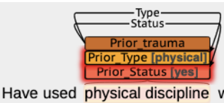

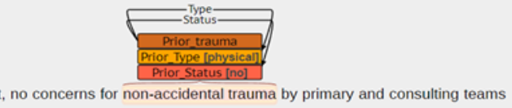



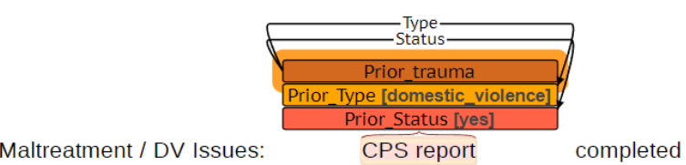

## (7) MENTAL health

Mental problems such as (e.g. depression, anxiety, suicide ideation) will be annotated for both patients and family members.

**(1) Trigger (required):** The trigger is the span that most clearly indicates a mental health event is present. The trigger span should be a noun phrase describing a mental health problem if present.

Table 14. Mental health trigger examples. Underlined words indicate the identified span.

|  |
| --- |
| **Examples** |
| No **post-partum depression** concerns in either parent. |
| Father has a history of autism spectrum disorder, **anxiety**, **depression**, and a prior history of alcohol and substance abuse. |
| Mother: **Anxiety**, **depression** treated with therapies only on/off over several years. Substance use/addiction. |
| Patient denies any thoughts of **suicide** or **self-harm** |
| Recent changes/stressors: reports **no stressors** right now. ( negative example) |
| Noted last year to have some **challenges balancing** being mom, wife and teacher with school online. Now she is happy to be returning to in person school. Recent **changes/stressors**: just COVID ( |
| SI/HI: Gets **mad easily at little things, sometimes feels sad**, feels like she has good support with her mother and friends at school Safety: Feels safe at home and at school |

**(2) Status (required):** ***Status indicates whether the mental health event is none, current, or past. Status annotation consists of assigning a label to mental health trigger.* The *Status* span should be the same as the *Trigger* span*.***

Table 15. Mental health- status examples. Underlined words indicate the triggers.

|  |  |
| --- | --- |
| **Status label** | **Examples** |
| none | Patient denies any thoughts of **suicide** or **self-harm** |
| current | Father has a history of autism spectrum disorder, **anxiety**, **depression**, and a prior history of alcohol and substance abuse. |
| past | Mother received treatment for **depression** prior moving to <LOCATION>. |



**(3) Experiencer (required):** *experiencer* indicates whether the *mental health* event is associated with the patient or parent / caregiver and ***consists of assigning a label to the mental health trigger.* The *Experiencer* span should be the same as the *Trigger* span*.***

Table 16. Mental health- experiencer examples. Underlined words indicate the identified trigger.

|  |  |
| --- | --- |
| **Experiencer label** | **Examples** |
| Patient | Patient denies any thoughts of **suicide** or **self-harm** |
| Parent / caregiver | Mother: **Anxiety**, **depression** treated with therapies only on/off over several years. Substance use/addiction. |
| Father has a history of autism spectrum disorder, **anxiety**, **depression**, and a prior history of alcohol and substance abuse. |

## (8) SUBSTANCE USE - ALCOHOL/DRUG/TOBACCO (PATIENT AND FAMILY SUBSTANCE USE HISTORY)

Alcohol, drug, and tobacco use will be annotated for both patients and family members. Drug events should involve marijuana, illegal drugs, or the abuse of prescription drugs. Drug events should not include the medical use (intended use) of pharmaceuticals.

**(1) Trigger (required):** The trigger is the span that most clearly indicates an alcohol, drug, or tobacco event is present. The trigger span should be a noun phrase describing a general substance type, like “alcohol,” “ETOH,” “tobacco history,” or “illicit drug use,” if present. If general substance types are not present, the span should be a relevant verb (e.g. “drink” or “smokes”) or a noun phrase describing a specific substance type (e.g. “cocaine” or “beer”).

Table 17. Substance trigger examples. Underlined words indicate the identified span.

|  |  |
| --- | --- |
| **Priority** | **Examples** |
| 1. Substance words | Alcohol none.  Does not consume alcohol.  He does not drink alcohol.  He denies tobacco use.  He has a history of illicit drug use…  He used to drink alcohol rarely…  …no ETOH.  mother was concerned about muscle stiffness and also notes **alcohol consumption** before finding out she was pregnant  He reports previous **drug use**.  **Tobacco Use** Smoking Status Never Smoker (Prioritize the header)  He has a h/o **meth** prenatally.  Feels safe at home, mom **vapes**, otherwise no **tobacco** or **drugs**, parents drink **alcohol** on occasion, no firearms.  **Smoking use**: none. Smokeless **tobacco**: none. |
| 2. Verb or substance type | Admits to heroin use…  …she does not drink…  He does drink six beers a day.  He has not smoked for the past <NUMBER/> years.  He does not smoke.  He has about 10 drinks a year.  …patient experimented with amphetamines, cocaine, marijuana**…** |

**(2) Status (required):** Status indicates whether the substance consumption is *none*, *current*, or *past*. The *none* label indicates the patient does not use the substance currently and has not used it in the past. ***Status annotation consists of assigning a label to the substance trigger.* The *Status* span should be the same as the *Trigger* span*.***

Table 18. Substance abuse- status examples. Underlined words indicate the triggers.

|  |  |
| --- | --- |
| **Status label** | **Examples** |
| none | The patient denies any **alcohol**.  He currently denies any **drinking**.  … she does not **drink**…  does not consume **alcohol**.  No **alcohol abuse**.  No history of **drug** or **alcohol abuse**.  She is a **nonsmoker** and **nondrinker**.  She uses no **illicit drugs**.  No use of **illicit drugs**.  He never used…**drugs**  **Alcohol** none. |
| current | She occasionally has **alcohol**.  He does have chronic **alcohol** use.  She **drinks** 2 to 3 glasses of wine…  Occasionally **drinks**.  Patient currently has 2-3 **drinks** per day.  He does **drink** six beers a day.  He is a social **drinker**.  She does have a history of chronic **marijuana use**.  Also admits today **using cocaine**.  He does **smoke**.  Social history: active **smoker**.  History of **drinking** for approximately <NUMBER/> years.  Occasional **alcohol use**. |
| past | He previously was an **alcoholic**…  She used to **smoke**…  She quit **smoking** in <YEAR/>.  He **used cocaine** in the past…  The patient experimented with **amphetamines**…  He admits to having **smoked marijuana**…  Personal history: He is an **ex-smoker**.  He has a history of **tobacco use** in the past. |

**(3) Experiencer (required):** *experiencer* indicates whether the *substance use* event is associated with the patient or parent / caregiver and ***consists of assigning a label to the substance trigger.* The *Experiencer* span should be the same as the *Trigger* span*.***

Table 19. Substance use - experiencer examples. Underlined words indicate the trigger span.

|  |  |
| --- | --- |
| **Experiencer label** | **Examples** |
| Patient | Patient denies any **drug use**.  **Smoking**: none  denies **drugs**, **smoking**, **tobacco**, **vaping**, **juuling**, **alcohol**  Social History: reports that he has never **smoked.** (Assume it is patient, by default.) |
| Parent / caregiver | Mother had hx of **drug abuse** and/or **alcohol abuse** |
| Biological father has a history of **substance abuse**, **alcohol abuse**, anxiety, depression, and PTSD. |
| No weapons or second hand **smoke** in home. |